**Lab 08 - Manage Virtual Machines**

#### **Task 1 and Task 2: Configure Azure virtual machines by using virtual machine extensions. Deploy zone-resilient Azure virtual machines by using the Azure portal and an Azure Resource Manager template.**

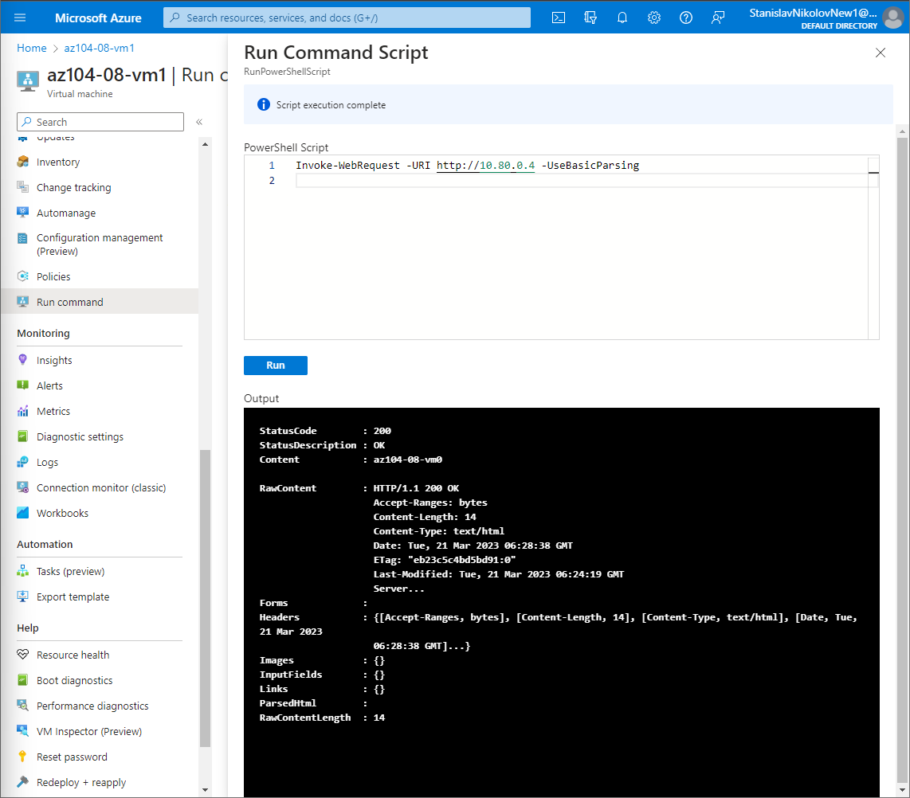

#### **Task 3: Scale compute and storage for Azure virtual machines.**

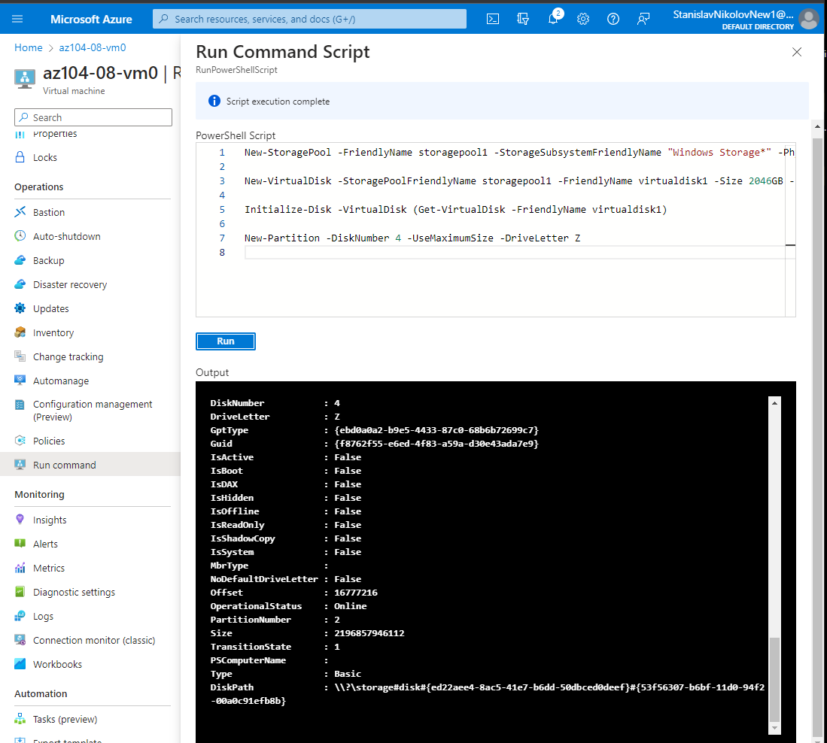

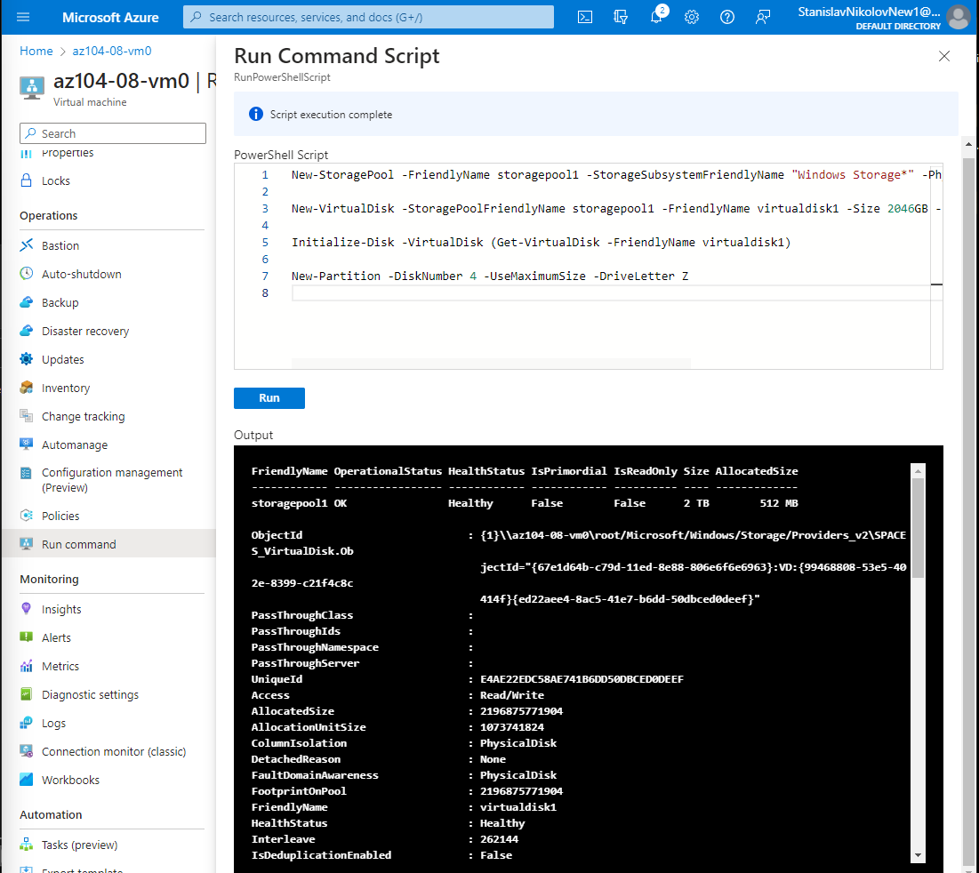

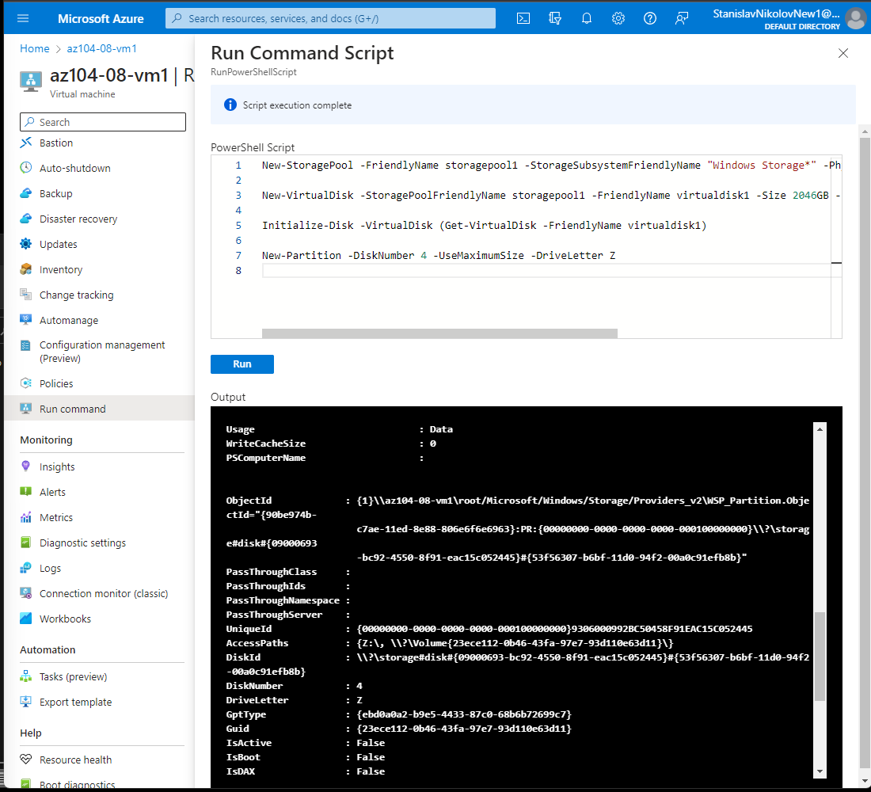

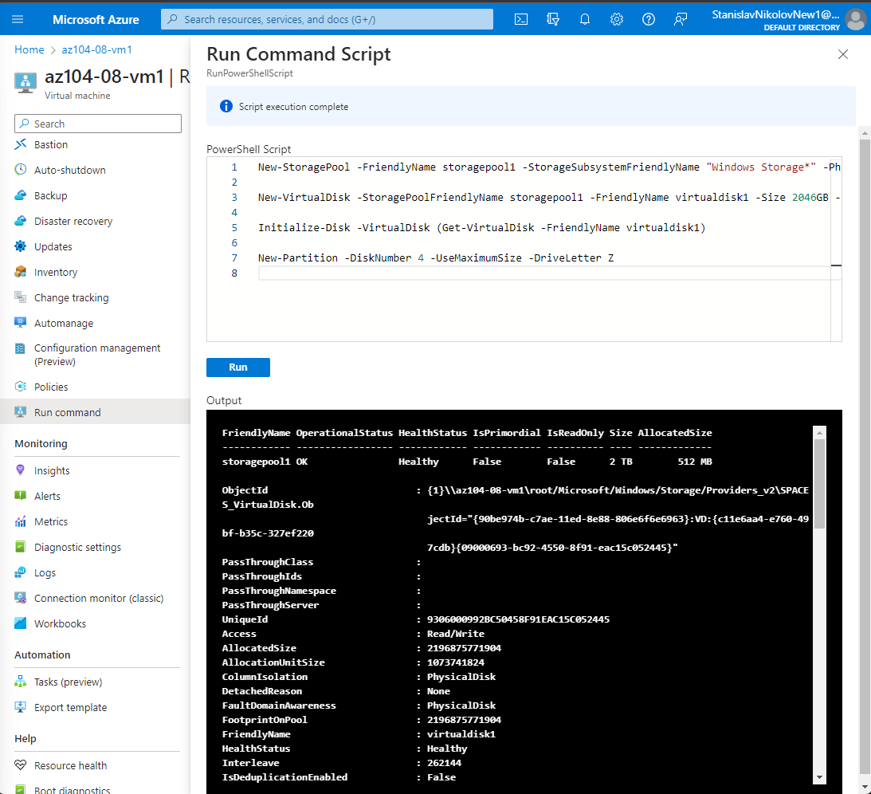

#### **Task 4: Register the Microsoft.Insights and Microsoft.AlertsManagement resource providers.**

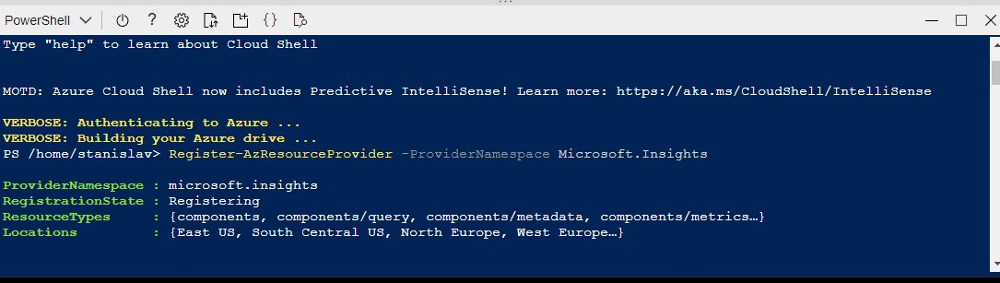

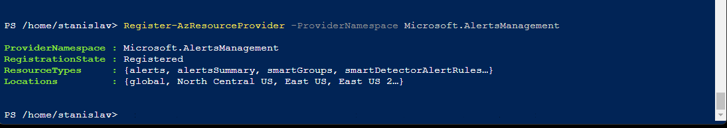

#### **Task 5: Deploy zone-resilient Azure virtual machine scale sets by using the Azure portal.**



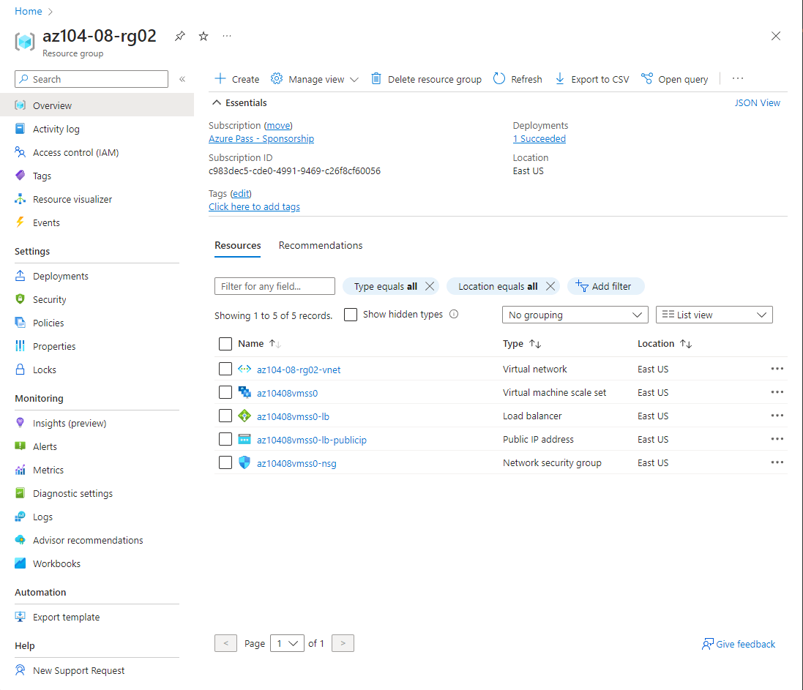

#### **Task 6: Configure Azure virtual machine scale sets by using virtual machine extensions.**

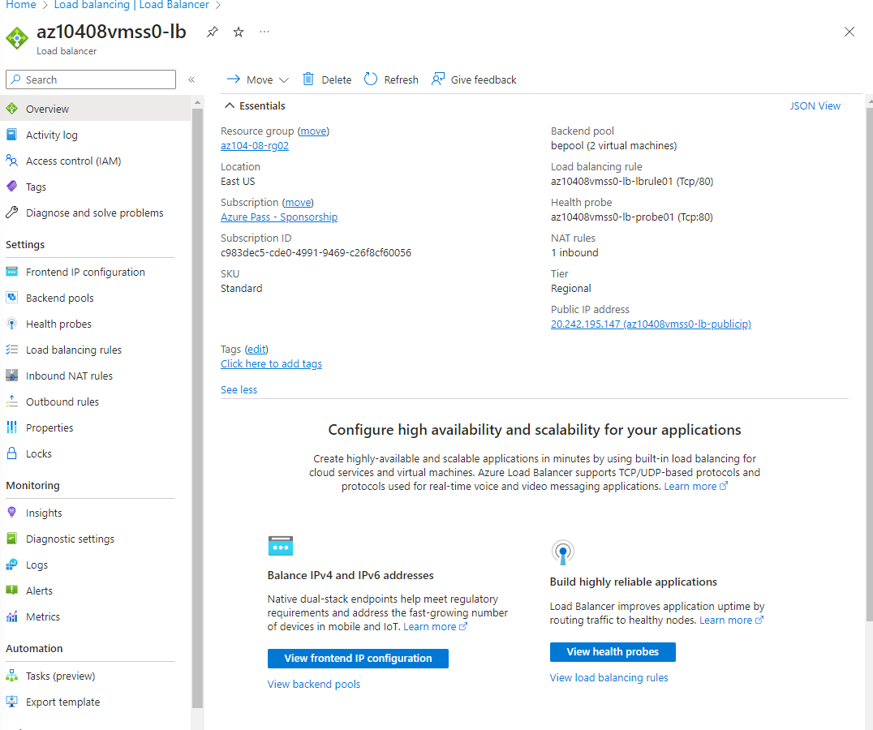

#### **Task 7: Scale compute and storage for Azure virtual machine scale sets.**

